Asssignment 7:
1.What is DDIC?
-> DDIC:
DDIC stands for Data Dictionary.
It is the central place in SAP where all database objects are defined and managed.
*It is a central repository used to create, manage, and maintain all data definitions used within an SAP system.
Central Repository: Stores metadata (definitions, types, lengths) for all SAP data objects.
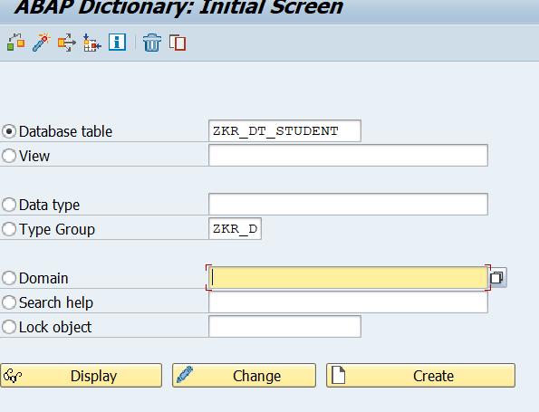

2.What is the TCode for ABAP Dictionary?
->SE11 (ABAP Dictionary): The primary transaction code for developers to create, view, and maintain DDIC objects

3.What are the object type available in DDIC?
->Database Table: A DDIC database table is a two-dimensional matrix that consists of rows and columns.
View: Virtual tables that combine data from one or more tables.
Data type: Here we can create data element.
Type group: Allow definition and grouping of non-predefined, complex, or constant types.
Domain: Define technical attributes like data type, length, and value range (fixed values or value table).
Search help: Provide input help (F4 help) for screen fields
Lock object: Manage synchronization of access to data by multiple users, often to prevent inconsistencies.
4. Difference between types of tables?
->3 type of tables
1.Transparent Table
2.Pooled Table
3.Cluster Table
1.Transparent table (One-to-one relationship) stores data directly in the database, and its structure in SAP matches exactly with the database table. It is mainly used for application data
2. pooled table stores data of multiple tables together in a single database table called a table pool. These are mainly used for control and system data.
3. cluster table stores related data from multiple tables together in a single database cluster. Data is stored in a compressed form and accessed using SAP logic. Or
(Several cluster tables are stored together in a single physical database table called a "table cluster".)
5.Difference between open SQL and native SQL?
->Open SQL is a database-independent SQL interface provided by SAP. It allows ABAP programs to access database tables without depending on the underlying database. The same Open SQL code works on any database supported by SAP, such as HANA, Oracle, or DB2. Open SQL automatically handles client fields, buffering, and security, making it safe and easy to use.
* Open SQL is portable and database-independent
* Open SQL is safer and easier to maintain
* Open SQL supports SAP features like buffering and client handling
* Open SQL contains the following keywords:
- SELECT - Reads data from database tables.
- INSERT - Adds lines to database tables.
- UPDATE - Changes the contents of lines of database tables.
- MODIFY - Inserts lines into database tables or changes the contents of existing lines.
- DELETE - Delete lines from database tables.
- OPEN CURSOR, FETCH, CLOSE CURSOR - Reads lines of database tables using the cursor.
->Native SQL is database-specific SQL that directly accesses the underlying database. It uses the syntax of the specific database being used, such as HANA SQL or Oracle SQL. Native SQL bypasses SAP’s database abstraction layer, so it does not support automatic client handling or buffering. It is mainly used when Open SQL cannot fulfill a specific requirement.
* Native SQL is database-dependent and not portable
* Native SQL offers more flexibility but requires deeper database knowledge.
* Native SQL does not support these features automatically

